MLA Style Guide
For Middle School

Guidelines for Formatting a Research Paper,
Making a Bibliography, and Documenting Sources

John Young Middle School
2016-2017

Introduction
The purpose of this handbook is to provide you with some guidelines on how to write your essays in MLA style. In the following pages you will find information about the basics of the style and how to correctly cite your sources. It is important to remember that in the space of this small handbook, only the most important elements of the style are covered; therefore, you may need to research other material in order for you to complete your assignments in MLA format.

Table of Contents
MLA Style Guide Basics
Plagiarism—What is it? How can I avoid it?
Formatting a Research Paper
Works Cited Page
Parenthetical Citation
Examples of Common Forms of Sources for Citation
On-line Tools and Resources for Writing Citations in MLA Format
Glossary

MLA Style Guide Basics
What is MLA Style?
The Modern Language Association (MLA) developed a style guide for academic writing. Part of the style guide deals with standardized ways to document the writer’s source materials.
MLA provides guidelines for the creation of a bibliography (called a “Works Cited” page) and the corresponding parenthetical (within the text) citation.

How do I use this MLA Style Guide?
Students and teachers in the middle schools are expected to use this MLA style guide when writing pieces that require information to be cited from other sources.

Why is it Important that I Cite Sources?
As a writer, it is your responsibility to give proper credit to your sources. It is also very important that you give this credit in accordance with MLA style. If you fail to give proper credit to a source, you have committed plagiarism. (See plagiarism)

Plagiarism—What is it? How can I avoid it?

What is plagiarism?
If you have not given proper credit to your sources, you have committed plagiarism. Essentially, it is like you are lying to your reader. You have used someone else’s ideas without telling your reader where you took it from.
Whether you have intentionally tried to pass off someone else’s ideas as your own or, through careless research, you unintentionally “forgot” to cite a source, the charge is plagiarism.

How can I avoid plagiarism?
Basically, any idea or fact that you received from a source needs to be cited. Any idea or fact that is common knowledge does not need to be cited. For example, facts like the Earth rotates around the sun or Abraham Lincoln was assassinated while in office are common knowledge and would not have to be cited.

Formatting a Research Paper

Margins
Except for the running head (see below), leave margins of one inch at the top and bottom and on both sides of the text.

Text Formatting
Always choose Times New Roman in which the regular type style contrasts clearly with the italic, and set it to the standard size of 12 points. Justify the lines of text at the left margin; turn off any automatic hyphenation feature in your writing program. Double-space the entire research paper, including quotations, notes, and the list of works cited. Indent the first line of a paragraph half an inch from the left margin. Indent set-off quotations half an inch as well. Leave one space after a period or other concluding punctuation mark, unless your instructor prefers two spaces.

Heading and Title
A research paper does not need a title page (unless your instructor requires one). Instead, beginning one inch from the top of the first page and flush with the left margin, type your name, your instructor’s name, the course, and the date on separate lines, double-spacing the lines. On a new, double spaced line, center the title (fig.1). Do not italicize or underline your title, put it in quotation marks or boldface, or type it in all capital letter.
Do not use a period after your title or after any heading in the paper. Begin your text on a new, double-spaced line after the title, indenting the first line of the paragraph half an inch from the left margin.
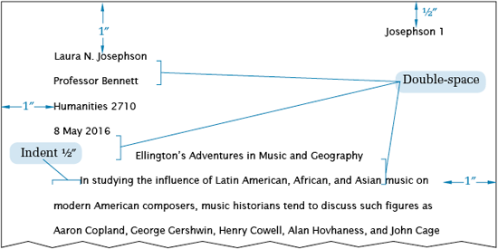
Fig. 1. The top of the first page of a research paper.

Running Head with Page Numbers
Number all pages consecutively throughout the research paper in the upper right-hand corner, half an inch from the top and flush with the right margin. Type your last name, followed by a space, before the page number (fig. 2). Do not use the abbreviation p. before the page number or add a period, a hyphen, or any other mark or symbol. Your writing program will probably allow you to create a running head of this kind that appears automatically on every page. Some teachers prefer that no running head appear on the first page. Follow your teacher’s preference.

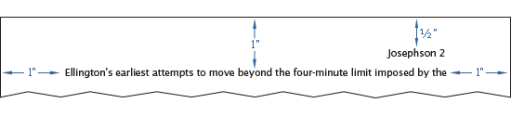
Fig. 2. The running head of a research paper.
Works Cited page

What is a “Works Cited” Page?
A Works Cited page is the name that MLA gives to a bibliography. It is a listing of all the sources you cited in the body of your paper.
Here are a few things to keep in mind about the Works Cited page:
- The Works Cited page is always going to be the last page of your essay or report. You should type the words Works Cited and center it on the page.
- Each entry must be complete and accurate. Examples of common sources in correct bibliographic format are included in this handbook.
- Each entry reads like one long sentence. What this means is that it does not matter where the second line begins in an entry; it begins on the second line only because you ran out of room on the first line.
- The second and subsequent lines are always indented five spaces.
- The sources are listed alphabetically by the first word or name of the entry. This first word or name should be what you use in your parenthetical citation.

Placement of the List of Works Cited
The list of works cited appears at the end of the paper. Begin the list on a new page. The list contains the same running head as the main text. The page numbering in the running head continues uninterrupted throughout. For example, if the text of your research paper ends on page 10, the works-cited list begins on page 11. Center the title, Works Cited, an inch from the top of the page (fig.3). (If the list contains only one entry, make the heading Work Cited.) Double-space between the title and the first entry. Begin each entry flush with the left margin; if an entry runs more than one line, indent the subsequent line or lines half an inch from the left margin. This format is sometimes called hanging indention, and you can set your writing program to create it automatically for a group of paragraphs. Hanging indention makes alphabetical lists easier to use. Double-space the entire list. Continue it on as many pages as necessary.

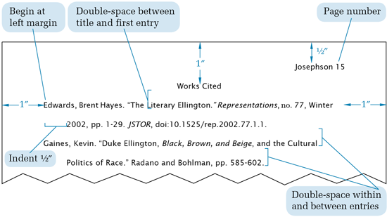
Fig. 3. The top of the first page of a works-cited list.

Example of a Works Cited page:
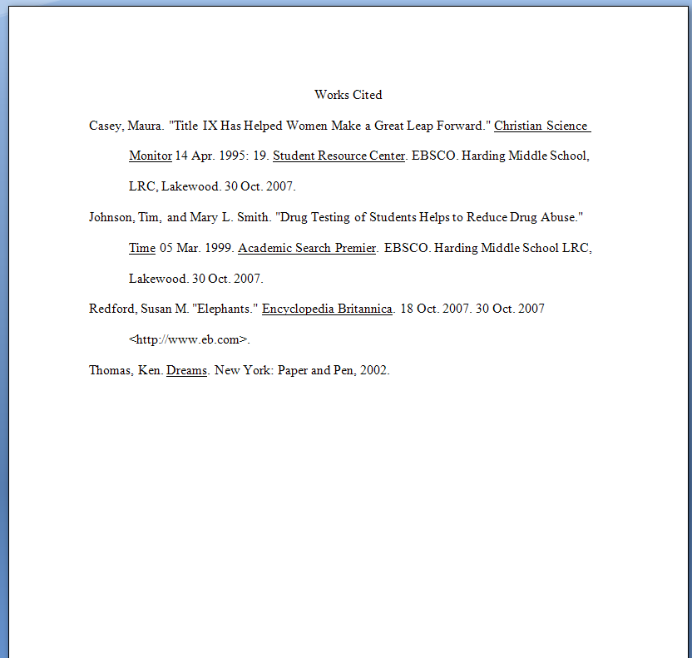

Parenthetical Citation

What is Parenthetical Citation?
Parenthetical citation is when a writer directly puts into the text a note from where he or she got the information. Parenthetical or “in-text” citation allows your reader to know from what source each idea/fact came.

This is how it looks in the text of your paper:
“In 2007, 37 percent of American adults sought medical information from the internet regarding a health problem they were experiencing before consulting a doctor.” (Smith 38)

In the example above, notice that the author’s name and the page number on which this fact was found are set off from the text within parenthesis. Note also that the punctuation of this parenthetical citation is also important. The reader would understand from this citation that on page 38 of Smith’s book, this fact is mentioned. Furthermore, since the words are contained within quotes, the above example illustrates that this is a direct quote from that page.
Here is an example of the same idea presented as in indirect quote:
Instead of going to a doctor right away, a recent study found that 37 percent of Americans are now tuning to the internet for medical information. (Smith 38)
See the difference between direct and indirect quotes in the glossary section.

Examples of Common Forms of Sources for Citation
** NOTE** The details are important in these citations--the order of the information, punctuation, underlining and quote marks all must be exact.

Print Resources (Viewed in Print Form)
Book by One Author
Last Name, First Name. Title. Place of publication: Publisher, Copyright
Date.
Example:
Jameson, George P. Ellis Island. New York: Icon Press, 2006

Book by Two Authors
Last name, First Name and First Name Last Name. Title. Place of publication:
Publisher, Copyright Date.
Example:
Smith, Henry G. and Betty Harmon. Freedom Rides. chicago: Broad Shoulder
Press, 2006.

Encyclopedia (NOTE: the author is usually listed at the end of the article. If an author is not listed, begin the entry with the title of the article.)
Last Name, First Name. “Title of Article.” Name of Encyclopedia. Edition
Year.
Example:
Franz, Charlene. “Goat.” World Book. 2006 ed.

A Work within an Anthology
Last Name, First Name. “Title of work.” Title of Anthology. Editor’s First
Name Last Name. Place of Publication: Publisher, Copyright Date.
Page numbers.
Example:
Stevens, Wallace. “Sunday Morning.” Modern American Poetry. Ed. Thomas J.
Hines. New York: Holt, Rinehart and Winston, 2003. 20-22.

Newspaper Article
Last Name, First Name. “Title of Article.” Newspaper Name Date: page(s).
Example:
Blake, Terry. “Attack in Bagdad: Two Marines Dead.” The Plain Dealer 20 July
2006: A1.

Magazine Article
Last Name, First name. “Title of Article.” Title of Magazine Date: page
numbers.
Example:
Thomasson, Ronald. “Salt Mines of Lake Erie.” Cleveland Magazine 15 may 2004:
23-25.

Non-Print Resources (Viewed Electronically)

Online Database--Encyclopedia
“Title of Article.” Name of Encyclopedia. Year. name of online source.
Date. <URL (Persistent link)>.
Example:
“Whale Oil.” Encyclopedia Britannica. 2006. Encyclopedia Britannica Online. 23
August 2006. <http://search.eb.com/eb/article-9076727>.

Internet Website
Last name, First Name. Title of Website. Date last updated. Author (if
given). Name of organization that sponsors the site. Date Accessed.
<URL link>.
Example:
Flannery O’Connor Collection. 7 July 2006. Georgia College and State University.
31 August 2006. <http://library.gcsu.edu/~sc/foc.html>.
Walker, Gary. “The Effects of Radiation.” Hiroshima Atom Bomb. 15 Mar. 2000.
Los Alamos Research Facility. 14 Oct. 2008.
<http://www.larf.org/hiro/radeffect.htm>.

TV/Radio Transcript
“Title of TV/Radio episode or segment.” Title of Program. Broadcast date.
Transcript. Name of Database Used. Date accessed. <URL link>.
Example:
“Special Edition: The War in Iraq Part II.” CNN Special Report. 5 April 2003.
Transcript. eLibrary. 27 March 2006. <http://elibrary.bigchalk.com>.

Video Documentary
Title of Film. Director’s First Name Last name. Copyright Year. Medium.
Production Company Name. Edition Date.
Example:
Finding Harmony. Kent Williams. 2003. DVD. Zen Buddhist Lecture Series Video.
2003.

On-Line Tools and Resources for Writing Citations in MLA Format

EasyBib.com
EasyBib.Com is an automated bibliography creator. The user fills in the required information in the separate fields and, with the press of a button, EasyBib creates the citation! EasyBib will export the list into Microsift Word in correct MLA format as a Works Cited page. The user must create a free account to login.

Purdue Owl
This website answers all questions you have about MLA Formatting of Papers, Parenthetical Citation and Works Cited pages. The link is: https://owl.english.purdue.edu/owl/resource/747/01/

Glossary

Bibliography--a listing of sources that a student used to write his/her essay or report.

Citation--is the identification of a specific idea or quote taken from a source.

Direct Quote--is a quote in which the author uses words from a source exactly as they were written. The words are taken verbatim. A direct quote is indicated by putting the words in quotation marks (“ “). A direct quote must be cited.

Indirect Quote--is a quote in which an author paraphrases, or puts into his/her own words, an idea from a source. An indirect quote must be cited.

Parenthetical Citation--is when a writer directly puts into the text a note from where he or she got the information.

Works Cited--is the name that MLA gives to a bibliography. It is the last page of an essay or report. It lists all of the sources the student has used in his/her writing.

